GIT COMMANDS
Git is a Local repository in our system

GIT stands for "Global Information Tracker"

In practical terms, Git is a "distributed version control system" used to track changes in source code
during software development. It helps multiple developers collaborate, keeps a history of changes, and allows you to revert to previous versions if needed.
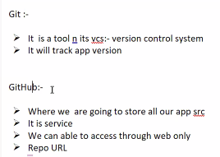
==============================================================
NOTE
create a file .gitignore in the server folder. Place in it all sensitive information like (.env), so that it will not push sensitive information in to the github repository.
=============================================================
Install the Git :
=====================
Download the Git for Windows installer from the official site:
👉 https://git-scm.com/download/win
Run the downloaded .exe file.
Follow the installation steps: (Keep other options as default)
Click Next through the setup.
Click Install and wait for the process to complete.
========================================================
D:\>git --version
git version 2.48.1.windows.1
If above not output coming, then verify
C:\Program Files\Git\bin
(If Git exists there, it means it's installed but not added to the PATH.)
Add following two paths in the Environment variables:
C:\Program Files\Git\bin
C:\Program Files\Git\cmd

===================================================================
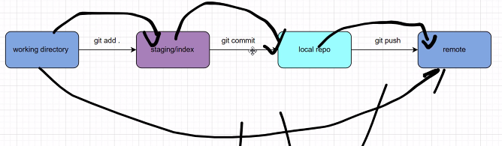
Git Commands:
========================================
Git (Distributed VCS)
-----------------------

1. Github account ( username, email)
2. install git in the local system

Configuration (One time enough)
--------------
$git config --list (github account, origin)

To logout github from local system

$git config --global --unset user.name
$git config --global --unset user.email
$git config --list

To Login GitHub/GitLab from Local System
$git config --global user.name "lakshmi"
$git config --global user.email " lakshmi@gmail.com"

------------------

1. Push
--------

step1: create repository in github (my-first-repo)
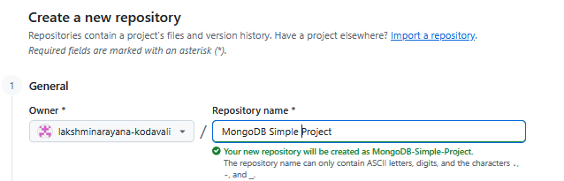
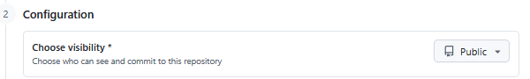
Click on “Create a Repository”

step2: In your laptop create or goto the folder which you want to push into the github.
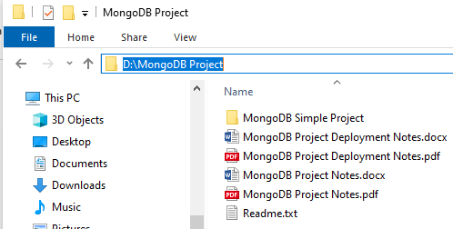
Select the path and type cmd, and press enter to open the command prompt

Execute the following commands (following commands will show by default in the github when you created a new repository), to push into the github.

git init
git add .
git commit -m "first commit"
git branch -M main
git remote add origin https://github.com/lakshminarayana-kodavali/MongoDB-Simple-Project.git
git push -u origin main

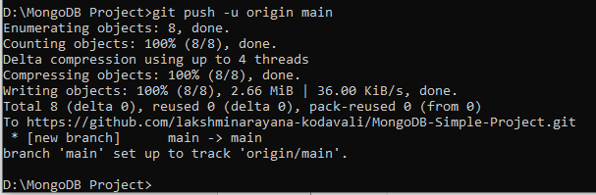
If you get any error like “origin already exist”
Execute the following two commands:
git remote remove origin
git remote add origin https://github.com/lakshminarayana-kodavali/MongoDB-Simple-Project.git

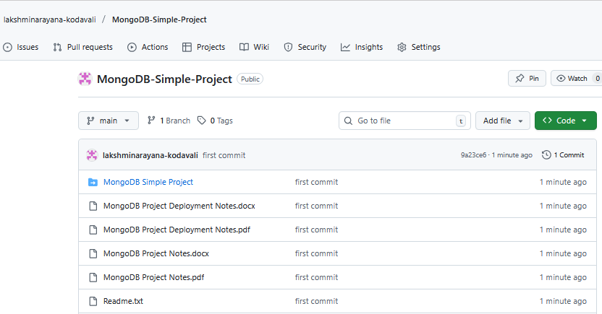
2. branch
---------

git branch //Lists all local branches in your repo
gti branch -a //It displays the current branch
git branch v1 //Creates a new branch v1
git checkout v1 //to redirect to the corresponding branch v1
echo "<h1>updated file</h2>" >> index.html
git add .
git status
git commit -m "file updated"
git push -u origin v1
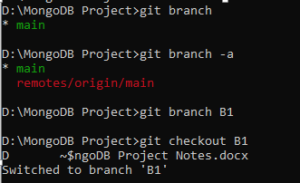
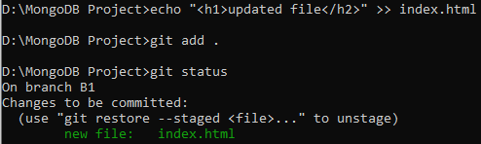
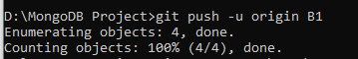
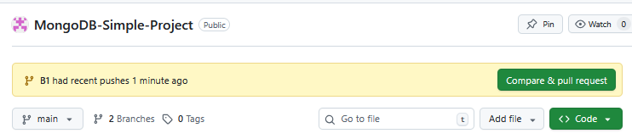
-----------------------------------------------------
3. To Merge B1 branch into the Main, do as follows:
git checkout main
git pull
git merge B1
git push origin main
Note: Refresh the browser and verify the content in the main branch.

Alternative method is click on the “Comare & Pull Request” Button in the Github as shown in the below screenshot.


=======================================
---------------------------------------------------------
4. delete branch (git branch -D branch_name)

To remove the branch B1

$git checkout main
$git branch -D B1
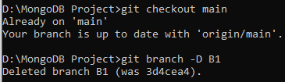

5. pull (Applicable when work with collaborative repositories)

Fetches changes from a remote repository and merges them into your local branch.

Use case: To update your local repository with the latest changes from the remote repo (e.g., changes made by teammates).
Direction: Remote → Local

$git pull origin main
-----------------------------------------------------------
6. clone (To download the project from the Github)

git clone repo_url
-------------------------------------------------------
7. log (TO get the log information)

git log
-------------------------------------------------------
8. rm (To delete a files from the repo)

git rm "temp.js"
git commit -m "Delete temp.js from main branch"
-----------------------------------------------
How to delete entire Repository:

Open the Repository

Go to “Settings”

Scroll to the Bottom – “Danger Zone”

Click “Delete this repository”
